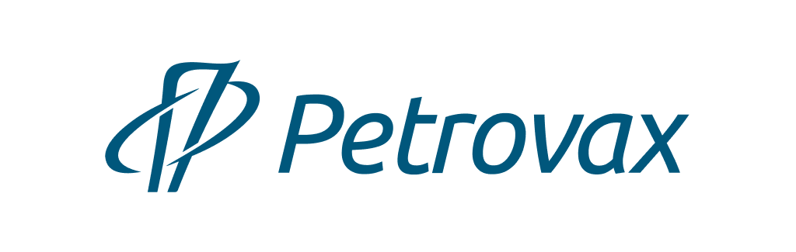
Pharmaceutical company Petrovax

Petrovax is a Russian full-cycle biopharmaceutical company with a 20-year successful experience of operating in the pharma market. It is a Top5 immunobiological manufacturer in Russia.
The product portfolio includes its own original pharmaceutical products and vaccines, generics, and localized products by lead pharma companies.
The company has an in-house R&D Center and invests heavily into R&D, which provides for launching and marketing in-demand pharmaceuticals and vaccines. Petrovax holds more than 20 new molecule and manufacturing process patents. The company has a certified vivarium with four types of laboratory animals used for clinical trials of own pharmaceutical products and providing CRO services.
The company’s manufacturing processes fully comply with the applicable Russian and international GMP standards and ISO:9001. Petrovax’s pharmaceutical manufacturing complex located in Moscow Region is one of the most high-tech biopharmaceutical facilities in Russia providing for manufacturing 160M shots of pharmaceutical products a year. The operations range from API synthesis to manufacturing a variety of dosage forms such as prefilled syringes, ampoules, vials, tablets, and suppositories. Petrovax is the first in Russia immunobiological manufacturer to be issued international GMP certificates by the EU and Iran’s authorities.
The company has a proven record of implementing international technology transfer projects related to full-cycle manufacturing, control, and quality assurance for immunobiological products. Petrovax’s partners are the world’s leading pharma companies such as Pfizer, Abbott, and Boehringer Ingelheim.
Presently, the company is successfully competing with the world’s industry leaders both in the domestic and foreign markets exporting its products to the EEU, Middle East (Iran), and EU (Slovakia). The prospective export areas are the South-Eastern Europe, Egypt and other MENA countries.
Petrovax has more than 500 skilled employees.
It is an Interros Group company.

Contacts:
NPO Petrovax Pharm, LLC
12 Presnenskaya embankment, Federation Tower East, Floor 38 (Moscow City), Moscow 123112, Russia
Phone: +7 (495) 730-75-45, e-mail: info@petrovax.ru, www.petrovax.ru

